Set background layer

# Description

In many cases before starting your work, it is necessary to set all elements in a drawing to a background layer in order to emphasazie on the scope of work which your drawing is intended for. This application changes all block definitions layer to “0” and afterward sets a background layer chosen by the user.

# How it works:

In the command line or on the screen type “NSVBACKGROUND”.

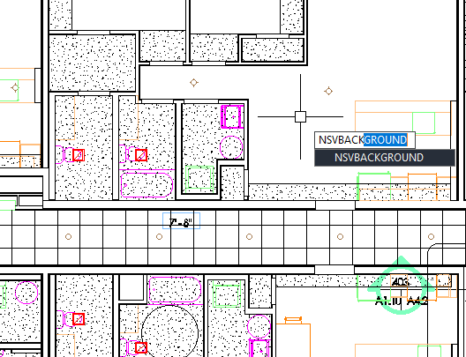

All blocks will change to layer “0”. Depending on your drawing size, this process may take some time. Then define the region which you want to set elements to a background layer. Afterward a dialog form appears which contains all layers in the drawing. From the drop down menue select the layer which you want to be set as a background layer and press “OK”.

